Title of Paper Should Be Centered, 14 pts New Times Roman Bold, and Caps and Lower Case

Name of presenting author, Name of co-author1, Name of corresponding author* (with asterisk)

Name of Department, Name of Institution
Complete mailing address
Name of City, Province / State
Country
Email of corresponding author: correspondingauthor@abc.edu.ph

The abstract must be submitted as a Word file; pdf files will not be accepted [1]. The abstract should not exceed one page, including figures, if any. All figures should be embedded in the document. The page dimension should be: 8.5” x 11” with 1” margin on all sides. Font: 12-points Times New Roman, single-spaced, justified [2].
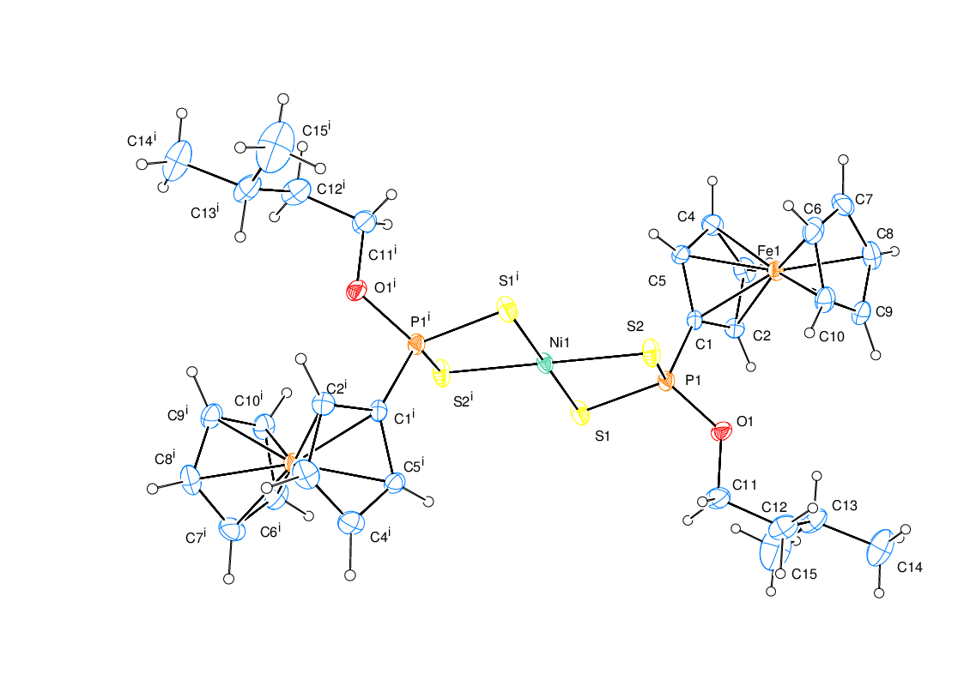
The quick brown fox jumps over the lazy dog. The lazy dog jumps over the quick brown fox. The quick brown fox jumps over the lazy dog. The lazy dog jumps over the quick brown fox. The quick brown fox jumps over the lazy dog. The lazy dog jumps over the quick brown fox. The quick brown fox jumps over the lazy dog. The lazy dog jumps over the quick brown fox. The quick brown fox jumps over the lazy dog. The lazy dog jumps over the quick brown fox. The quick brown fox jumps over the lazy dog. The lazy dog jumps over the quick brown fox. The quick brown fox jumps over the lazy dog. The lazy dog jumps over the quick brown fox. The quick brown fox jumps over the lazy dog. The lazy dog jumps over the quick brown fox. The quick brown fox jumps over the lazy dog. The lazy dog jumps over the quick brown fox. The quick brown fox jumps over the lazy dog. The lazy dog jumps over the quick brown

Figure

References

[1] I. Haiduc, L.Y. Goh, Coord. Chem. Rev. 2002, 224, 151-170.

[2] P.K. Gogoi, J. Sonowal, Indian J. Chem. Technol. 2005, 12, 50-54.

